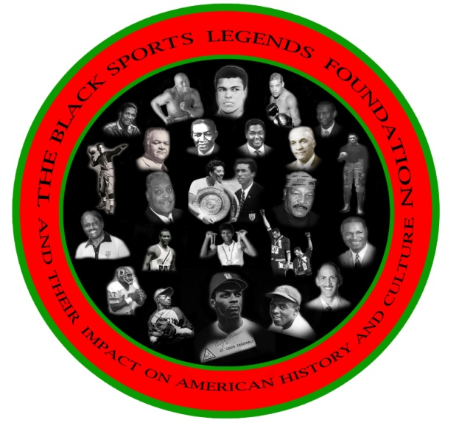
CEO (BSLF) Ronald K. BETHEA
Board Of Directors
Frank Coles
Wayne R. Frazier
Vince Robinson
Frank Simpson
Floyd E. Taliaferro, III

FOR IMMEDIATE RELEASE

January 31, 2014
Contact: Ronald K. Bethea
202-246-4924
rkb@theblacksportslegendsfoundation.org

THE BLACK SPORTS LEGENDS FOUNDATION PLANNING COMMITTEE TIMELINE FOR THE NATIONAL EMAIL AND LETTER WRITING CAMPAIGN FOR THE INDUCTION OF RAYMOND CHESTER INTO THE 2015 NFL PRO FOOTBALL HALL OF FAME CLASS
On October 5, 2013, the Black Sports Legends Foundation, a 501 C 3 nonprofit organization announced the formation of a planning committee headed by Derrick Ramsey, Athletic Director of Coppin State University, to get Raymond Chester nominated to the NFL Pro - Football Hall Of Fame for the class of 2015. The announcement occurred at the 2013 Pre-Game Memorial & Celebration , on the campus of Morgan State University.
On February 3, 2014, a press conference is being co - sponsored by the Morgan State University Student Government Association (SGA), at the Student Center located at 1700 East Cold Spring Lane Baltimore, Maryland 21251 in room 210 at 3:00 p.m., on the campus of Morgan State University. The Press conference will provide further details on the composition of the planning committee for the campaign.
The strategies that will be implemented will include the following : Engaging the Morgan State University School of Communications Student Organization , Morgan State University National Alumni Association office and the Morgan State University Baltimore City Howard Cornish Chapter. We will also be contacting the Superintendants Of Schools for the Baltimore, City Public Schools, and Oakland, California City Public school system to get public school students engaged in the national email voting campaign. We have contacted the public relations department for the Oakland Raiders, which we plan to engage to generate emails and letters from the Oakland Raider's Nation fan base to jump start the national email and letter writing campaign.

We will also be reaching out to members of the Black College Football Hall of Fame, headed by Doug Williams and James Harris, and members of the NFL Pro- Football Hall of Fame. Local and national sports writers and sports broadcasters will move the campaign forward by emailing the NFL seven - man member senior committee.
Press releases and public service announcements will be distributed to WEAA 88.9 F.M. and all Baltimore local television and radio stations concerning the email campaign.
Please take a minute of your time to visit our website at www.theblacksportslegendsfoundation.org and, click on the photo gallery to view the 2013 Pre-Game Memorial & Celebration.
______________________________________________________________________________________
Charged with the vital task of continuing to ensure that new enshrines are the finest the game has produced is the Pro Football Hall of Fame's 46-person Selection Committee (see list below).
FAQ about the Hall's selection process
The Committee consists of one media representative from each pro football city with two from New York, inasmuch as that city has two teams in the National Football League. A 33rd member is a representative of the Pro Football Writers of America and there are 13 at-large delegates.
How is a Senior Candidate Chosen?
To assure that older players will be considered, along with the Modern Era players, a Seniors Committee, made up of nine veteran members of the overall Selection Committee, has been established to consider nominees whose active career has been completed by at least 25 years.
Like the full Committee, the members of the Seniors Committee are provided a preliminary list of eligible nominees. The list, which is compiled and mailed to the selectors by June 1, includes carry-over nominations from the previous year, first-time eligible candidates, and nominations from any outside source. By way of a mail ballot the Committee members reduce the list to 15 Senior Nominee finalists. Five members of the nine-man Committee, selected on a rotating basis, are designated to attend the annual Seniors Committee meeting held in Canton, where they are charged with the responsibility of nominating two candidates from that list to be among the 17 finalists for Hall of Fame election. In advance of the meeting, each selector is provided with detailed biographical information on the candidates.
Senior Committee members are assisted during their annual meeting by two Hall of Fame consultants, chosen by the Hall’s president, who were contemporaries of the majority of the nominees. The consultants offer only their opinions and are not entitled to vote. After each candidate is discussed thoroughly, the consultants are excused from the meeting. Additional discussion is conducted followed by a series of reduction votes that results in the naming of two Senior Nominees.
Although the Senior Nominees will be presented to the full Selection Committee as two of the 17 finalists, their election to the Hall of Fame is not automatic. The Senior Nominees must receive the same minimum 80% of the vote as a Modern Era candidate to be elected.

Pro Football Hall of Fame Selection Committee
Arizona | Kent Somers, Arizona Republic
Atlanta | Len Pasquarelli, CBS-Atlanta
Baltimore | Scott Garceau, WMAR-TV
Buffalo | Mark Gaughan, Buffalo News
Carolina | Darin Gantt, ProFootballTalk
Chicago | Dan Pompei, Chicago Tribune*
Cincinnati | Joe Reedy, Cincinnati Enquirer
Cleveland | Tony Grossi, ESPNCleveland.com/WKNR Radio
Dallas | Rick Gosselin, Dallas Morning News*
Denver | Jeff Legwold, ESPN.com
Detroit | Anwar Richardson, MLive!
Green Bay | Cliff Christl, Green Bay Press-Gazette
Houston | John McClain, Houston Chronicle*
Indianapolis | Mike Chappell, Indianapolis Star
Jacksonville | Sam Kouvaris, WJXT-TV
Kansas City | Randy Covitz, Kansas City Star
Miami | Edwin Pope, Miami Herald
Minnesota | Mark Craig, The Minneapolis Star-Tribune
New England | Ron Borges, Boston Herald*
New Orleans | Pete Finney, Times-Picayune
New York (Giants) | Bob Glauber, Newsday
New York (Jets) | Gary Myers, New York Daily News
Oakland | Frank Cooney, The Sports Xchange
Philadelphia | Paul Domowitch, Philadelphia Daily News
Pittsburgh | Ed Bouchette, Pittsburgh Post-Gazette
St. Louis | Bernie Miklasz, St. Louis Post-Dispatch*
San Diego | Nick Canepa, San Diego Union Tribune
San Francisco | Nancy Gay, Comcast Sportsnet
Seattle | Mike Sando, ESPN.com
Tampa Bay | Ira Kaufman, Tampa Tribune
Tennessee | David Climer, The Tennessean
Washington | David Elfin, 106.7 The Fan
PFWA | Darryl Ledbetter, Atlanta Journal-Constitution
At Large | Howard Balzer, The Sports Xchange
At Large | Jarrett Bell, USA Today
At Large | John Clayton, ESPN/ESPN Magazine
At Large | Jason Cole, Yahoo! Sports
At Large | John Czarnecki, FOXSports.com*
At Large | Dave Goldberg, AOL Sports/Fanhouse*
At Large | Clark Judge, CBSSports.com
At Large | Peter King, Sports Illustrated
At Large | Ira Miller, The Sports Xchange*
At Large | Sal Paolantonio, ESPN
At Large | Vito Stellino, Florida Times Union
At Large | Jim Trotter, Sports Illustrated
At Large | Charean Williams, Ft. Worth Star Telegram
* Also serves on the Senior Selection Committee.

NFL PRO FOOTBALL HALL OF FAME SENIORS COMMITTEE VOTERS
1.) Dan Pompei* Former sports columnist Chicago Tribune - Twitter - Dan Pompei @ danpompei
2.) Rick Gosselin, Dallas Morning News* - email - rgosselin@dallasnews.com
3.) John McClain, Houston Chronicle* email- john.mcclain@chron.com
4.) Ron Borges boston herald*- email ron.borges@bostonherald.com
5.) Bernie Miklasz, St. Louis Post-Dispatch* email- bjmiklasz@post-dispatch.com
6.) John Czarnecki* At Large - email - John Czarnecki, msn.foxsports.com
7.) Dave Goldberg At Large* - email - dgoldberg@ap.org

