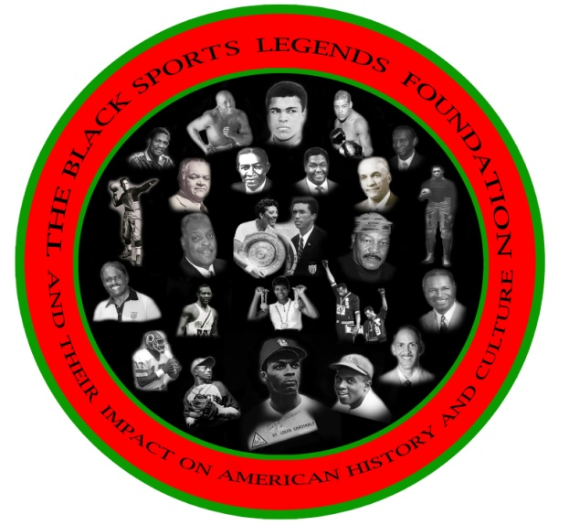
CEO (BSLF) Ronald K. BETHEA
Board Of Directors
Frank Coles
Wayne R. Frazier
Vince Robinson
Frank Simpson
Floyd E. Taliaferro, III

FOR IMMEDIATE RELEASE OCTOBER 8, 2013

2013 PRE- GAME HOMECOMING MEMORIAL & CELEBRATION AND 2014 COLLEGIATE FILM FESTIVAL TOUR PREVIEW

Dear Friends:

As president and CEO of the Black Sports Legends Foundation (BSLF), I sincerely thank you for your support and attendance at the 2013 PRE- GAME HOMECOMING MEMORIAL & CELEBRATION AND 2014 COLLEGIATE FILM FESTIVAL TOUR PREVIEW ON OCTOBER 5, 2013. We also appreciate the opportunity to recognize, remember, honor and present to our coaches and players The BSLF TRAILBLAZER CERTIFICATE OF APPRECIATION AND THE 2013 TRSILBLAZERS AWARD. That went to Mr. Raymond Chester former Morgan State University and Oakland Raider NFL great. The BSLF is also greatful for all the alumni and friends who shared in this historical homecoming memorial service.

The presentation of our Trailblazer Certificate Of Appreciation recognizing
the memory of our Paper Bear, Earl Banks, and the many other coaches and players who contributed to the history, legacy and traditions of excellence in athletics at MSU was a great honor to our students and community.

A special thanks to Raymond Banks, Wayne Frazier, Herb Lynch, Jimmy Lewis, Dr. Miles Harrison, Rashad Staton Vice President MSU SGA , Stanley Tucker, George Nock, Eugene Neal, Dr. David Wilson President of Morgan State University and Mr. Kweisi Mfume Chair of Morgan State University's Board of Regents, GROOVE PHI GROOVE, IOTA PHI THETA, Willie Lanier, Bob Wade, Lenard Braxton, William Brent, and the many coaches, players, alumni and friends who supported this event with their participation and attendance.

The BSLF also recognizes and appreciates the words of encouragement from Derrick Ramsey, Athletic Director of Coppin State University as he announced the formation of a Planning Committee to consider the nomination of Raymond Chester for induction into the NFL Hall of Fame. We also want to give out a special thanks to Raymond Chester who traveled from Oakland California to be with us. We also want to thank The Clark Construction Group, LLC for sponsoring the event.

Please support The Black Sports Legends Foundation so we can bring to you. The 2014 Colligate Film Festival Tour back to Morgan State University on February 6, 7, 8, 2014 . To support the athletic programs through your financial donation, sponsorship and attendance.

You may view the web site at www.theblacksportsfoundation.org for more detailed instructions and information about donation and sponsorship opportunities.

Your presence, financial donations and sponsorship support are needed and appreciated.

Sincerely,

Ronald K. Bethea
President/CEO, BSLF
202-246-4924

