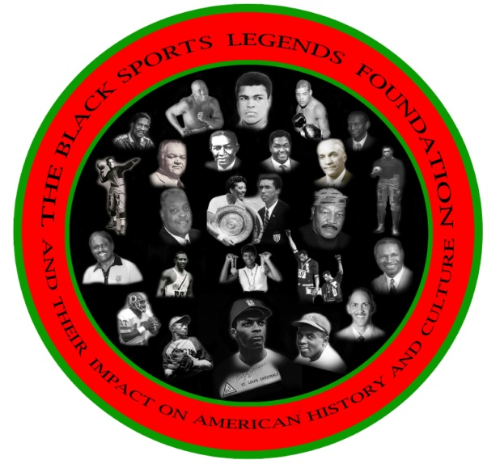Ronald K. Bethea, CEO, BSLF

Board Of Directors

Frank Coles

Wayne R. Frazier

Vince Robinson

Frank Simpson

Floyd E. Taliaferro, III

**IMMEDIATE RELEASE**    **OCTOBER 15, 2013**

**The Black Sports Legends Foundation (BSLF) 2014 Collegiate Film Festival Tour Preview**

Dear Alumni and Friends,

The BSLF sincerely thanks you for your support at the 2013 PRE GAME HOMECOMING MEMORIAL & CELEBRATION" on  October 5, 2013 at Morgan State University. The event was a resounding success. Please read our October 8, 2013 press release attachment.

As CEO of BSLF which is a 501C 3 non-profit organization, I along with BSLF Board of Directors member Mr. Vince Robinson, recently met with Ms. Barbara Blount, Armstrong Corporations and Foundations Officer, and Mrs. Henri Banks, with MSU's Office of Institutional Advancement, to learn how the foundation can establish an endowment and term **SCHOLARSHIP FOR OUR STUDENT ATHLETES AT MSU.**  The foundation plans to raise scholarship funds through our three-day **2014 Collegiate Film Festival and Night with the Legends Banquet and corporate fundraising efforts. The film festival will be held at MSU on February 6, 7, 8 2014.**

Please support the Morgan State University athletic programs through your sponsorships or financial donations to The Black Sports Legends Foundation.

Please go the website at [www.theblacksportsfoundation.org](http://www.theblacksportsfoundation.org/) for more detailed instructions and information about donation and sponsorship opportunities.

Your presence at the February event, financial donations and sponsorship support are needed and appreciated.

Thank you,

Ronald K. Bethea

President/CEO

Black Sports Legends Foundation

202-246-4924