***CAN NORTHERN BLACKS LEARN SOMETHING FROM THE SO-CALLED BLACK SOUTHERN BAMA IN 2014?***

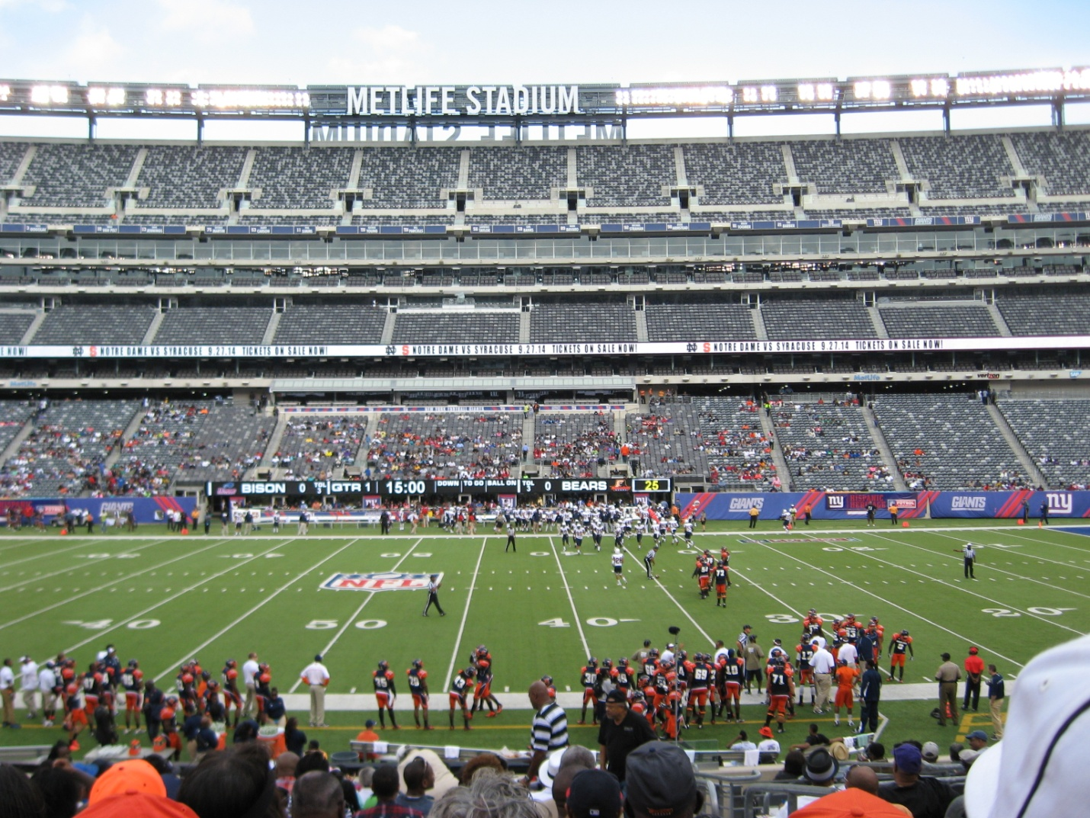***As I sat down to write this article, as an African-American sports historian, about one of this nation's oldest football classic games, my thoughts took me back in time to what was originally referred to as the Morgan vs. Grambling game. The first game was played in 1968 at Yankee Stadium in front of over 68,000 African-American fans. In 1971, the game was renamed the New York Urban League Whitney Young Football Classic. I played in that particular game that had an attendance of over 64,000 African-American fans. It was the ABC Sports' featured game as the ABC game of the week. This was the first time that black colleges appeared on a national television telecast, which featured two of the legendary coaches of the 1970's era, Grambling Coach Eddie Robinson and Morgan State Coach Earl Banks. CBS Sports has produced a documentary film titled "1st and GOAL from the BRONX," that chronicled the color and pageantry of black college football during the golden era of black college football.***

***I chose the title for this article because as a student athlete at Morgan State College, transferring from Claflin College in Orangeburg, South Carolina and growing up in Dillon South Carolina, I often would hear many fellow students, from Washington DC., Baltimore, MD., Philadelphia PA., and New York City refer to black folks from the Deep South as Bamas.***

***Today, as I look back over the years and the many black college homecomings and classic football games in the deep South, Mid Atlantic and North that I have attended, I see a very disturbing trend among northern blacks, many of whom live with the illusion of inclusion that they are fully integrated into white society and many of whom have forgotten about their own institutions and culture. This trend translates into the fact that northern blacks are more comfortable spending their money with white institutions and white businesses and subsequently allow black businesses to go out of business for lack of support from northern black consumers.***

***The statistical data on HBCUs classic football game attendance clearly bears out the facts that black folks living from Washington, D.C. to New York City market areas in the northeastern region of the United States have the highest per capita family household incomes in the United States for African Americans. Many of them have lost their cultural identity when it comes to supporting black college homecomings and black college football classics.***

***For example, here in Washington D.C. the AT&T Football Classic which has been played in RFK stadium has not been able to draw 25,000 fans in three years. This year's 2014 game attendance only drew 13,178 fans at RFK stadium, which has a capacity of 55,000 fans for football. Over the past three years AT&T has been the major sponsor, and this is the last year on the four-year contract which AT&T has chosen not to extend for the future.***

***In 2013, The New York Urban League Classic game's attendance was 15,000 tickets sold. An estimated crowd of 25,000 fans for the tailgate party with MetLife stadium has capacity of 82,500. This year’s 2014 New York Urban League football classic game attendance was a disgrace. The official attendance numbers for the game attendance was 28,712 but if you watched the national game broadcast on ESPN the attendance was truly embarrassing.***

***According to an article in the Black College Sports Page titled "The Attendance Matters in 2013," the downward trend in black college football attendance continued in 2013 based on numbers compiled by the Black College Sports Page. The following numbers show this trend.***

***HIGHEST ATTENDANCE AT 2013 BLACK COLLEGE FOOTBALL GAMES***

***1. MAGIC CITY CLASSIC Legion Field, Birmingham, Alabama A&M vs. Alabama State: 63,113***

***2. BAYOU CLASSIC SUPER DOME, NEW ORLEANS GRAMBLING vs. SOUTHERN: 47,385***

***3. FLORIDA CLASSIC CURTIS BOWL, ORLANDO, FLORIDA A&M vs. BETHUNE-COOKMAN: 45,000***

***4. SOUTHERN HERITAGE CLASSIC LIBERTY BOWL, MEMPHIS JACKSON STATE vs. TENNESSEE STATE 42,400***

***5. SWAC CHAMPIONSHIP GAME RELIANT STADIUM, HOUSTON SOUTHERN vs. JACKSON STATE 38,985***

***6. ATLANTA CLASSIC GEORGIA DOME, ATLANTA S.C. STATE vs. NC A&T 35,412***

***7. SOUTHERN UNIVERSITY HOME GAME MUMFORD STADIUM, BATON R., LA. SOUTHERN vs. JACKSON STATE: 30,816***

***8. STATE FAIR CLASSIC COTTON BOWL,DALLAS, TEXAS PRAIRIE VIEW A&M vs. GRAMBLING: 27,745***

***9. TUSKEGEE UNIVERSITY HOMECOMING.TUSKEGEE, ALA. TUSKEGEE vs. CENTRAL STATE: 27,549***

***10. SOUTHERN UNIVERSITY HOMECOMING MUMFORD STADIUM, BATON ROUGE, LA. ALCORN vs. SOUTHERN: 27,102***

***I only chose the top ten games, although the list provided data for the classic fifteen and the top twenty homecoming games by attendance. The numbers for game attendance topping 20,000 was down from 22 to 15 in the 2013 season. The average attendance at those games was slightly up from 29,514 to 31,174. The Magic City Classic (63,113), Bayou Classic (47,385) and Florida Classic (45,000) retained the top three positions on the list. The top 20 homecoming games were about the same --just over 16,000 fans per contest. Tuskegee (27,549) and Southern (27,102) topped the homecoming list.***

***Not one of the top classic games or homecoming was any further north than the state of Virginia. Numbers don't lie in this case, it's clear that black folks living in the market demographics -- from Washington D.C. to New York City and further north need to think before the open their mouths and referring to black folks living in the deeper south as a BAMAS.***

***The late great father of soul music, James Brown, used to say: "Talking Loud and Say Nothing." Black folks, please buy tickets and support the New York Urban League Football Classic on September 20, 2014, Morgan State University vs. Howard University. The future of whether black college football programs and our black institutions will survive depends on how we spend our entertainment dollars, along with the fact that our HBCU institutions must do a better job marketing their programs.***