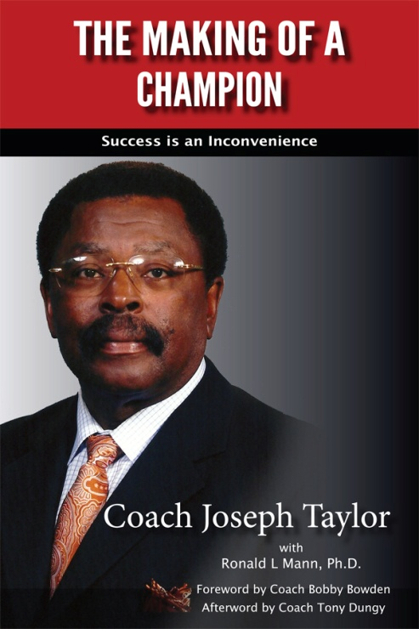$14.99 eBook | $24.95 paperback

**ABOUT THE MAKING OF A CHAMPION**

Foreword by Coach Bobby Bowden

Afterword by Coach Tony Dungy

The Making of a Champion: Success is an Inconvenience is an extraordinary book about football and life. As the subtitle implies, success is not easy. In this book, Coach Taylor shares the real hard truth about what it takes to succeed in life, both on and off the field. He lays out his successful blueprint that addresses both the path for individual greatness, and the organizational plan required for a championship football team. He is so loved by his ex student-athletes that many have come forward to share their stories about playing with Coach. NFL players such as Marcus Dixon (NY Jets), Kendall Langford (St. Louis Rams), and Corey Swinson (St. Louis Rams) provide personal memories and insights into Coach Taylor’s success and method. Harvard professor Timothy Benson, M.D., attorney Jonathan Hunt, Orthopedic Surgeon Tim Frazier, M.D., Head Football Coaches Michael Bailey and Coach Donald Hill-Eley, and many others share riveting stories about the demands and rewards of playing ball with Coach Taylor. Dr. Frazier is a Navy doctor assigned to the Marines. He recently returned from Afghanistan. When asked what was more difficult, being in the Marines or playing ball for Coach Taylor, he replied without a breath, “Playing ball for Coach Taylor.”

Joe Taylor believes in the development of the total person, mind, body and soul, in order to create a wining athlete and a great human being. His work is his ministry and he has devoted his life to the development and transformation of these young men. He is a tough love kind of guy. As Corey Swinson shares in his story, “Many will come, but only few will be chosen, and those who are chosen will choose themselves.” Those who chose to stay discovered a level of greatness that changed their lives. Their stories provide the proof and documentation for Coach Taylor’s blueprint. This book is not only educational, but it is profoundly inspirational.

The Fellowship of Christian Athletes is one strong component of the blueprint. The Reverend Jerome Barber, details his time and approach with Coach Taylor’s teams over his years at Hampton University. Rev. Barber shares the Bible passages and the inspirational teachings that were given to these young men. The reader will be touched and inspired by this important discussion.

The final section, Football 101, provides a “behind the scenes” understanding of football from defense to offense and special teams. Anyone who loves to watch football, or wants to learn more about the game, will find value in this discussion.

This is a must read for anyone who loves the game, coaches the game, or has children involved in sports. In addition, anyone who wants to take his or her life to the next level will find tremendous value in this book. Coach Taylor has been inducted into three separate Hall of Fames. Learn from a legend and an expert– read this book!

**"Stay in the Circle" Free Sample Audio Chapter**