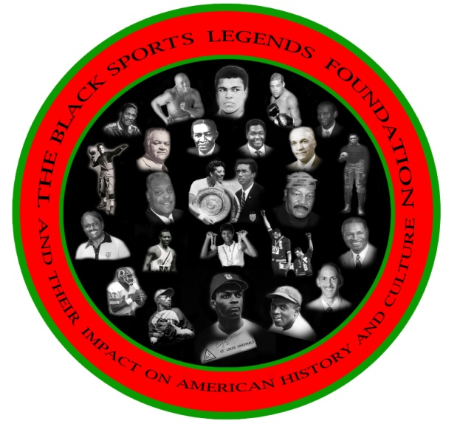**Ronald K. BETHEA**

**CEO, BSLF**

**Board of Directors**

**Frank Coles**

**Wayne R. Frazier**

**Vince Robinson**

**Frank Simpson**

**Floyd E. Taliaferro, III**

**FOR IMMEDIATE RELEASE**

**January 21, 2014**

**Contact: Ronald K. Bethea**

**202-246-4924**

**rkb**[**@theblacksportslegendsfoundation.org**](mailto:RKB@theblacksportslegendsfoundation.org)

**2014 FEBRUARY FILM FESTIVALS SCHEDULED AT HOWARD UNIVERSITY AND MORGAN STATE UNIVERSITY CANCELLED FOR LACK OF CORPORATE SUPPORT**

**In 2010, the Black Sports Legends Foundation (BSLF), a 501 (c) (3) non-profit organization, launched a film festival at Morgan State University (MSU). The film festival was a three-day event showcasing documentary films designed to educate today's youth on African-American sports legends, who have had a major impact on American history and culture. The films were produced from the perspectives of some of the top film producers using one of the most powerful mediums that reach today's youth. The foundation used the medium of film to bring together sports figures and film producers at various historically black colleges and universities to speak to students and community attendees about their lives and to discuss why they chose to give back to their communities. We invited the alumni associations and athletic booster clubs from each university and asked the public to make donations to help raise scholarship dollars for student athletes presently attending their universities.**

**As president and CEO of the Black Sports Legends Foundation (BSLF), I sincerely thank you for your support and attendance at the 2013 PRE- GAME HOMECOMING MEMORIAL & CELEBRATION AND 2014 COLLEGIATE FILM FESTIVAL TOUR PREVIEW ON OCTOBER 5, 2013.  We also appreciate the opportunity to recognize, remember, honor and present to our coaches and players The BSLF TRAILBLAZER CERTIFICATE OF APPRECIATION AND THE 2013 TRAILBLAZERS AWARD that went to Mr. Raymond Chester, former Morgan State University and Oakland Raider NFL great. The BSLF is also grateful for all the alumni and friends who shared in this historical homecoming memorial service.**

**The presentation of our Trailblazer Certificate of Appreciation recognizing**

**The memory of our Paper Bear, Earl Banks, and the many other coaches and players who contributed to the history, legacy and traditions of excellence in athletics at MSU was greatly appreciated by our students and community.**

**A special thanks to Raymond Banks, Wayne Frazier, Herb Lynch, Jimmy Lewis, Dr. Miles Harrison, Rashad Staton, Vice President MSU SGA , Stanley Tucker, George Nock, Eugene Neal, Dr. David Wilson, President of Morgan State University, and Kweisi Mfume, Chair of Morgan State University's Board of Regents, GROOVE PHI GROOVE, IOTA PHI THETA, Willie Lanier, Bob Wade, Lenard Braxton, William Brent, and the many coaches, players, alumni, and friends who supported this event with their participation and attendance.**

**The BSLF also recognizes and appreciates the words of encouragement from Derrick Ramsey, Athletic Director of Coppin State University, as he announced the formation of a Planning Committee to consider the nomination of Raymond Chester for induction into the NFL Hall of Fame. We also want to give a special thanks to Raymond Chester who traveled from Oakland, California to be with us. We also want to thank The Clark Construction Group, LLC for sponsoring the event.**

**We would like to inform the public about those corporations from whom we have solicited sponsorship funding, who felt that spending their sponsorship dollars to fund a film festival of this nature for the African American community was not important. We have established The Black Sports Legends Foundation Corporate Hall of Shame List so that the black community will know where we have sought funding within the private and public sectors so that we may spend our consumer dollars accordingly, and become more educated about the matching requirements in the public funding sector. Such requirements for 501 C 3 non- profit organizations disproportionately affects non-profit organizations headed by African Americans. You can log on to our website at www.theblacksportslegendsfoundation.org to view a copy of the list.**

**If you wish to become a contributor or donor to the foundation and for more information, please log on to** [**www.theblacksportslegendsfoundation.org**](http://www.theblacksportslegendsfoundation.org/index.html); **click on the events flyer or contact Ronald K. Bethea, CEO, The Black Sports Legends Foundation, 202-246-4924, P.O. Box 60207, Washington, DC 20039 or** [**www. theblacksportslegendsfoundation.org**](http://www.theblacksportslegendsfoundation.org/index.html)