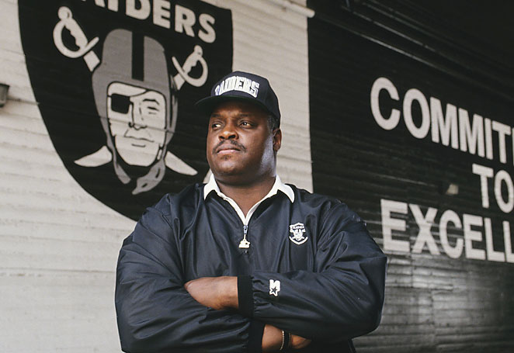ART SHELL INDUCTED COLLEGE FOOTBALL HALL OF FAME ATLANTA

**ATLANTA —**University of Maryland Eastern Shore alumnus and Hall of Famer, Art Shell, will be inducted tomorrow in the College Football Hall of Fame in a ceremony held in Atlanta.  Shell, an alumnus of then Maryland State College in 1968, is already an NFL Hall of Famer and the modern era’s first African-American NFL head coach.

The event, in coordination with the National Football Foundation (NFF), will be broadcast live on ESPN3 at 7:30 p.m. A press conference starts the activities tomorrow at 11 a.m.  It will be hosted by the Omni Hotel at CNN Center in Atlanta and is sold out.

The event will be emceed by award-winning broadcaster **Wes Durham**. In addition to the enshrinement ceremonies, the show will feature a preview of the 2013 college football season by a panel of top television analysts, including **Tony Barnhart, Desmond Howard** (a 2010 inductee into the College Football Hall of Fame), **Mark Schlabach** and **Matt Stinchcomb** (the 1998 recipient of the NFF William V. Campbell Trophy).

Shell is being inducted as part of the Division College Football Hall of Fame, which, according to its mission statement, honors players and coaches from the NCAA Football Championship Subdivision, Division II, Division III and NAIA. In the 1960s, UMES competed in the Central Intercollegiate Athletic Association, a Division II conference.

"This is a truly exceptional group of College Football Hall of Fame inductees from the divisional ranks," said NFF Chairman Archie Manning in the official press release. "We look forward to celebrating their accomplishments, and we applaud them for reaching the pinnacle of recognition in our great sport."

Shell played four seasons with the Hawks from 1964-1967. He was a two-time All-American as an offensive and defensive lineman in his junior and senior seasons plus earned All-CIAA honors his final three years. He would go on to have a strong professional career with the Oakland Raiders, being inducted into the Pro Football Hall of Fame after winning three Super Bowls and making eight Pro Bowls.

Shell is part of a seven-member 2013 Divisional College Football Hall of Fame Class along with Elby Jordan, Joe Micchia, Jeff Wittman, Frank Cignetti, James "Boots" Donnelly and Jess Dow.  He is one of 24 members of the overall class of 2013 and also includes:

**Charles Alexander** (LSU), **Otis Armstrong** (Purdue), **Steve Bartkowski** (California), **Hal Bedsole** (Southern California), **Dave Casper** (Notre Dame), coach **Frank Cignetti** (West Virginia, Indiana [Pa.]), **Ty Detmer** (BYU), coach **James “Boots” Donnelly** (Austin Peay State, Middle Tennessee State), coach **Jess Dow** (Southern Connecticut State), coach **Phillip Fulmer** (Tennessee), coach **Jimmy Johnson** (Oklahoma State, Miami [Fla.]), **Shelby Jordan** (Washington University in St. Louis [Mo.])**, Tommy Kramer** (Rice), **Joe Micchia** (Westminster College [Pa.]), **Art Monk** (Syracuse), **Greg Myers** (Colorado State), **Jonathan Ogden** (UCLA), **Gabe Rivera** (Texas Tech), **Mark Simoneau** (Kansas State), coach **R.C. Slocum** (Texas A&M), **Scott Thomas** (Air Force), **Jeff Wittman** (Ithaca College [N.Y.]) and **John Wooten** (Colorado).