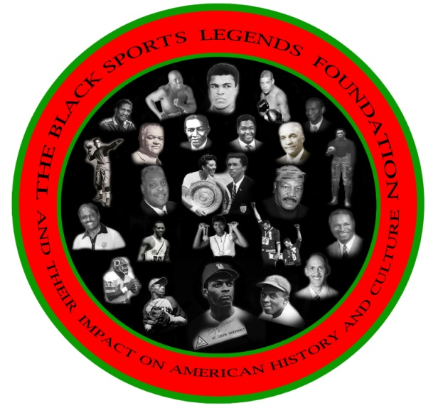
FOR IMMEDIATE RELEASE

August 25, 2013
Contact: Ronald K. Bethea
202-246-4924
rkb@theblacksportslegendsfoundation.org

The Black Sports Legends Foundation To Present A 2013 Film Festival Tour Preview And Homecoming Memorial & Celebration
2014 Film Festival to be held at Howard University and Morgan State University

In 2010, the Black Sports Legends Foundation (BSLF), a 501 (c) (3) non-profit organization, launched a film festival at Morgan State University (MSU). The film festival was a three-day event showcasing documentary films designed to educate today's youth on African-American sports legends, who have had a major impact on American history and culture. The films were produced from the perspectives of some of the top film producers using one of the most powerful mediums that reach today's youth. The foundation will use the medium of film to bring together sports figures and film producers at various historically black colleges and universities to speak to students and community attendees about their lives and to discuss why they chose to give back to their communities. We will invite the alumni associations and athletic booster clubs from each university and ask the public to make donations to help raise scholarship dollars for student athletes presently attending their university.
The festival will end with a dinner titled, "Night with the Legends," which will feature past and present professional athletes who attended each college or university. Proceeds from the dinner will also help raise scholarship dollars for student athletes attending that college or university.

On October 5, 2013, from 8 a.m. to 12 p.m., The 2013 Film Festival Tour Preview Homecoming Pre-game Memorial Celebration, will also provide an opportunity for alumni and friends to pay tribute to players and coaches who have passed on, remember, honor, recognize and celebrate the history and legacy of MSU championship football teams from the CIAA and MEAC. It will also serve as to prelaunch the planning committee for the future nomination and induction of Raymond Chester into the National Football League Pro-Football Hall of Fame. The memorial will feature several special guest speakers. All alumni and former players are invited the event will be held at the MSU Student Union Center Amphitheater.
The BSLF will present a preview showing of several featured films, such as "1st and Goal from the Bronx," "The Morgan Lacrosse Story," and the "Papa Bear," documentary featuring the legendary Earl Banks. All films will be presented in full showing at the 2014 Black Sports Legends Foundation film festival, which will be held at the above mentioned universities.
For more information, log on to www.theblacksportslegendsfoundation.org, click on the events flyer or contact Ronald K. Bethea, CEO, The Black Sports Legends Foundation, 202-246-4924, P.O. Box 60207, Washington, DC 20039 or www. theblacksportslegendsfoundation.org
SPONORED BY CLARK CONSTRUCTION GROUP, LLC

