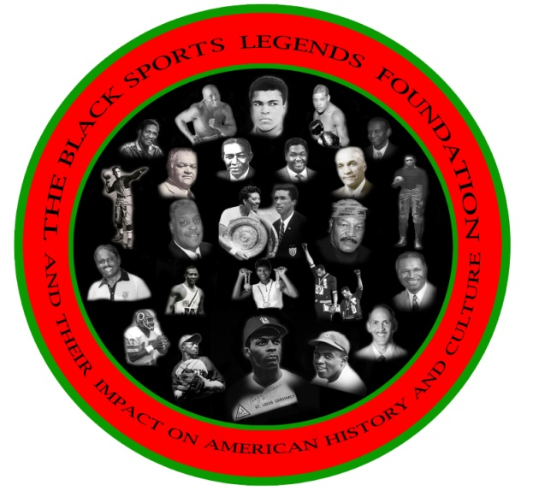

**FOR IMMEDIATE RELEASE:**

**August 19, 2013**

**Contact: Ronald Bethea & Vincent Robinson**

**Phone: 202-246-4924 or 443-681-0708**

**THE BLACK SPORTS LEGENDS FOUNDATION TO PRESENT A 2014 COLLEGIATE FILM FESTIVAL TOUR PREVIEW AND 2013 HOMECOMING MEMORIAL CELEBRATION**

**"45th Year Anniversary"**

**"The 1968 Morgan vs. Grambling Football Game"**

**Dear Fellow Alumni,**

**The Black Sports Legends Foundation (BSLF) will present a 2014 Collegiate Film Festival Tour Preview, 2013 Homecoming Celebration and Memorial Service on Saturday, October 5, 2013 before the homecoming game at the Morgan State University Student Union Center Theatre, from 8:00 a.m. to 12:00 noon.**

**The purpose of the event is to honor, remember and recognize the greatness of the athletes, coaches and fans who contributed to the History, Legacy and Traditions of excellence in athletics at Morgan State University.**

**Let's reunite and cherish the accomplishments of those legendary coaches, athletes and fans who obtained greatness through their achievements and performances on and off the field.**

**ADDMISSION FREE**

SPONSORED BY CLARK CONSTRUCTION GROUP, LLC